*Annie Williams*

*AT3 | 321541L*

*external task*

Website design and documentation

*The design process*

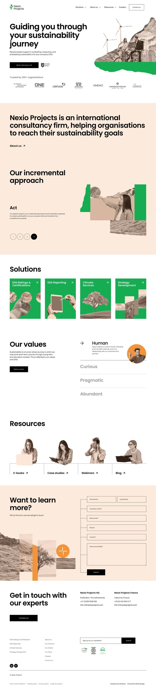*Investigation*

*Home Page*

Contrast is shown through colours, as it was used to separate the pages.

Repetition of colours, shapes and design techniques like typography were used over the whole page which created a cohesive design. The colours also create interest and contrast.

Alignment, all the images are centred to one side of the screen whilst the text is opposite, this created a page that is easy to read and follow.

Proximity was used a lot as all elements have white space between them. This space allows the page to hold a lot of content without being overwhelming.

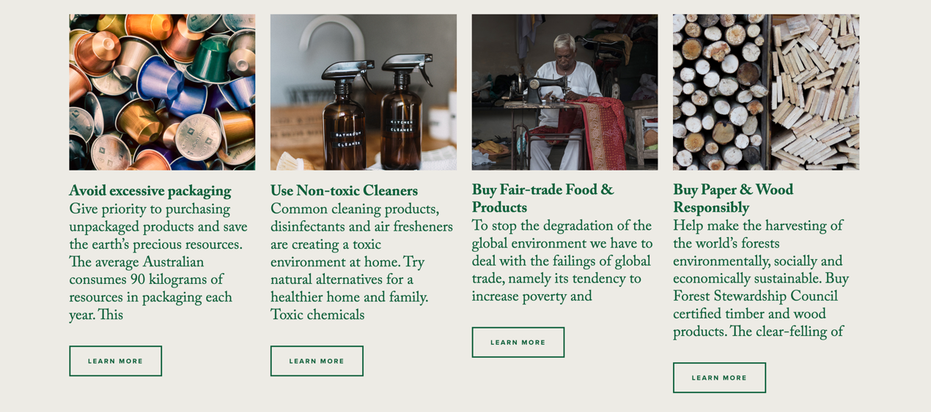

*Shop page*

Contrast was shown through images, and shading. Whilst the colours used are similar the shades differ and allows the text to be easily read.

Repetition of the same card for the product as well as the same layout shows a cohesive design.

Alignment, all images are the same size and shape whilst the paragraphs are different heights the content still looks even and neat on the page.

Proximity, the cards for each product are close together but the page does not feel crowed as the typography used is small and the shape of the paragraph changes from each product.

*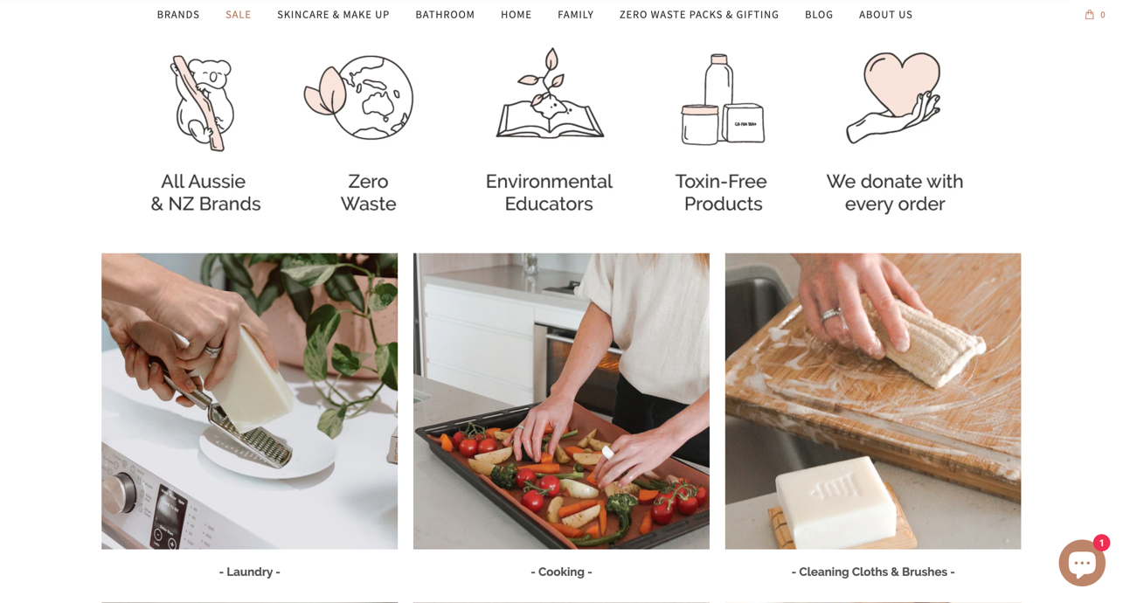Content page*

Contrast, the light colours and background contrast harshly with the dark text allowing for each piece to be read easily.

Repetition, icons with similar images are used above and then images of the same size below create a difference in the way content is displayed but how they can still work well together.

Alignment, the content is all centred around the middle of the page with each element such as text being centred to the image above, also being centred.

Proximity, all content is within close proximity and there isn’t much white space, but because of other design choices the page doesn’t feel crowded.

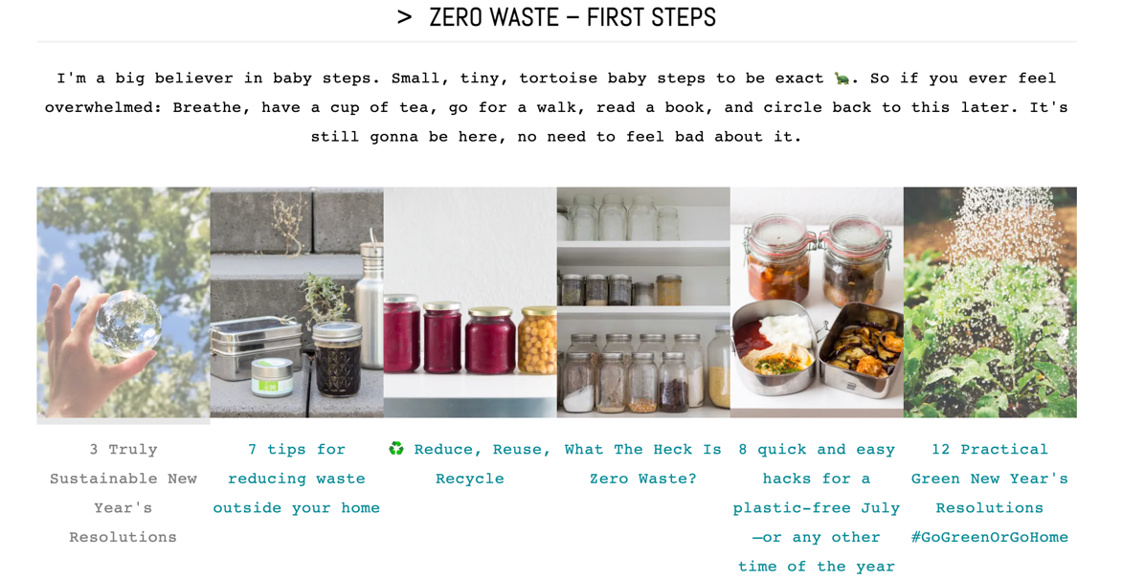Contrast, this page doesn’t use much contrast besides from the text, as this page focuses on the images.

Repetition, the images and links repeated throughout create an easy-to-follow page and the repetition of font and colour create a design that looks neat.

Alignment, the images are used as links and the title of the link is below, this is shown through the alignment of the images. The text and all content is centred either within the middle of the page or below the text.

Proximity, the images are close together creating a break in the page to sperate content, this is effective in showing the information in different sections.

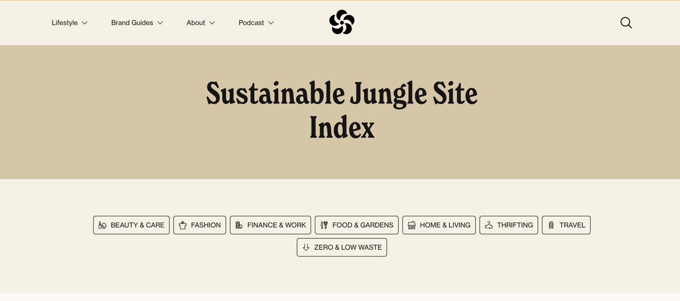Contrast, the different shades of brown create sections on the page. The bold dark text in the centre of the page stands out and draws the readers attention.

Repetition of fonts within body and navigation bar and the repetition of icons create consistency within the design.

Alignment, all content is centred around or below the logo, indicating the importance of the logo.

Proximity, the different shades of brown, each a different size demonstrates each section of the website. Each link is evenly spaced, and all follow the same design with an icon and text.

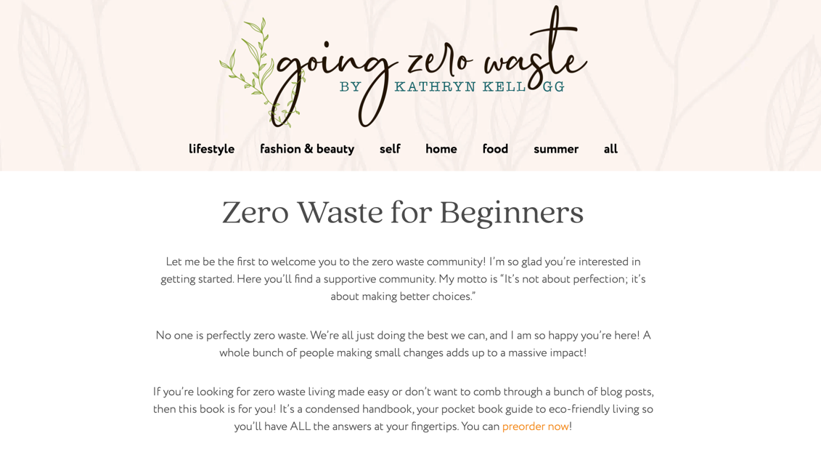Contrast, the colour of the text stands out against the light background making it easy to read, and the logo is much darker and bold standing out more.

Repetition, the same fonts were used for body texts and the colours are consistent throughout the design.

Alignment, all content is centred on the page, below the logo. The text is only as wide as the navigation bar.

Proximity, the text are further spaced apart as the font it lighter, so having it further apart allows it to be read easily.

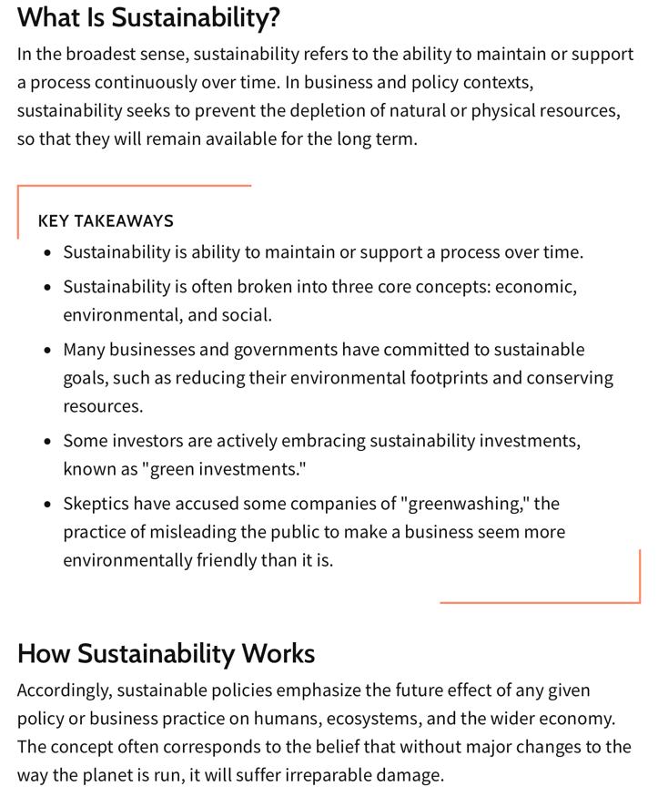Contrast, the text and background are opposite colours and therefore contrast whilst the orange corners to break apart the block of text. The orange stands out against the rest of the colour scheme.

Repetition, the same font is repeated throughout with heading being bold and the body text normal.

Alignment, the writing it to one side of the page, allowing the text to be split into columns.

Proximity, the text and headings are evenly spaced with the ‘key takeaways’ box being placed further away creating more white space around it, so it stands out more.

* After looking at various different website I see common themes such as colours, images and layouts as well as common products and ways of displaying content for this specific genre
* Many of these websites were created in a blog, and whilst these are effective, I want to show information in a different way such as shown beside in a question answer or heading and text format.

*Investigating summary*

The design brief for this task was to create an 8–10-page website under a specific topic, using a range of stylistic features. The topic of the chosen final product is ‘building a sustainable lifestyle’, focusing on individuals and how their lifestyles can be altered lower their environmental impact, as well as why it is important to do so. The website is designed for web use on full screen and will consist of 8 pages total. Each page will use a range of stylistic features to showcase the information as shown below in the wireframes. This project is aimed at young adults who are conscious about their environmental impact. The target audience of the website heavily dictated how these pages were designed with the characteristics of the audience being taken into consideration. Many pages have minimal text so the pages can be easily skimmed quickly, and the information is absorbed through other elements such as images, lists, and tables. The target audience was also taken into consideration when choosing colours, as choosing lighter and brighter colours will appeal to younger people. The task has the time frame of 9 weeks to complete both the website and documentation so the design must be achievable to create within this timeframe. Within the set timeframe, smaller due dates are set to keep the project on track. This includes the wireframes and investigation to be done by the end of the first month and a start to be made on the documentation.

|  |  |  |
| --- | --- | --- |
| Hardware | | |
| Device | Use | Why? |
| MacBook | To create the website, and record all data | This was used to design and produce the website, as the software and programs where on this device. |
| iPhone | To gather and edit images. | The phone was used to edit images for the software installed |
| Software | | |
| Program | Use | Why? |
| Word | For documentation, to record, store progress images, and keep ideas | This program was used as it is accessible and holds all the tools needed to create and document the process. |
| Figma | This software was used to create the wireframes | This program is designed specifically for this use and make designing the pages easy. |
| Sublime Text | This software was used to hold both the html and CSS code. | Sublime text allows all the coding to be accessed in one location and is a program that I was familiar with. |
| GitHub | GitHub was used to create a repository and make the website live. | This allows for any issues to be able to be traced back and the page to be constantly saved as new modifications are made. |

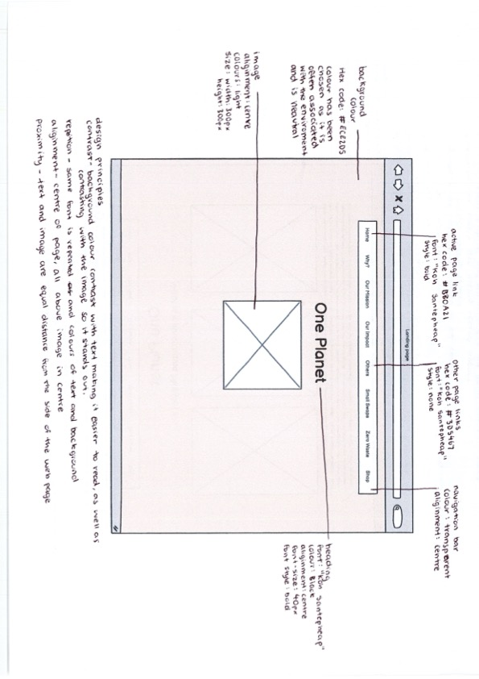As detailed within the wireframes the design principles, contrast, repetition, alignment, and proximity (CRAP) are taken into consideration. This CRAP principles are present throughout the pages as it creates a consistent design. Within the final product these techniques will be used to make a cohesive and well thought out design, which reaches its target audience.

Word count: 481

Devising

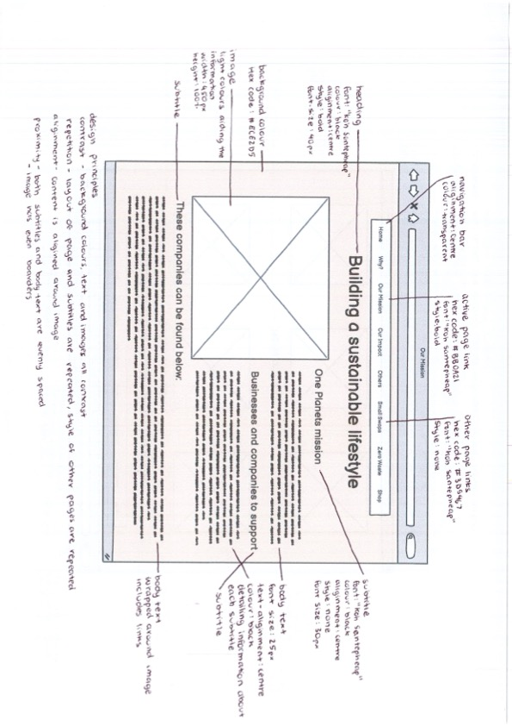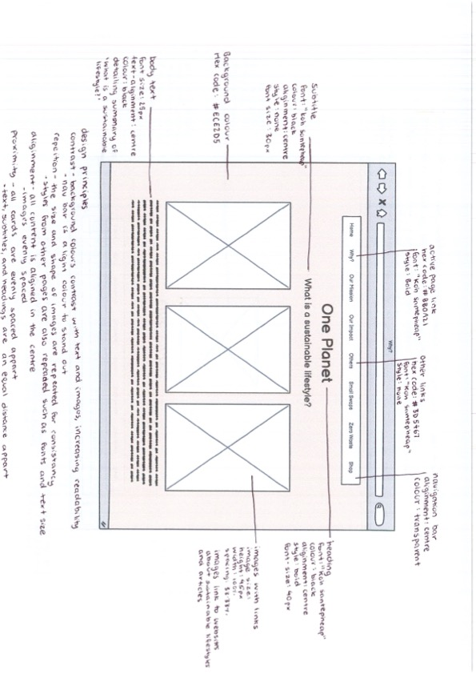

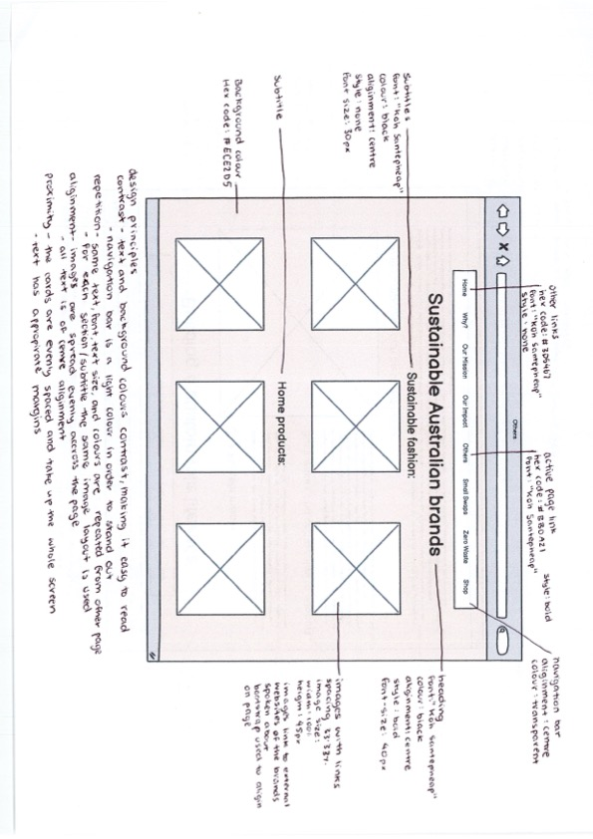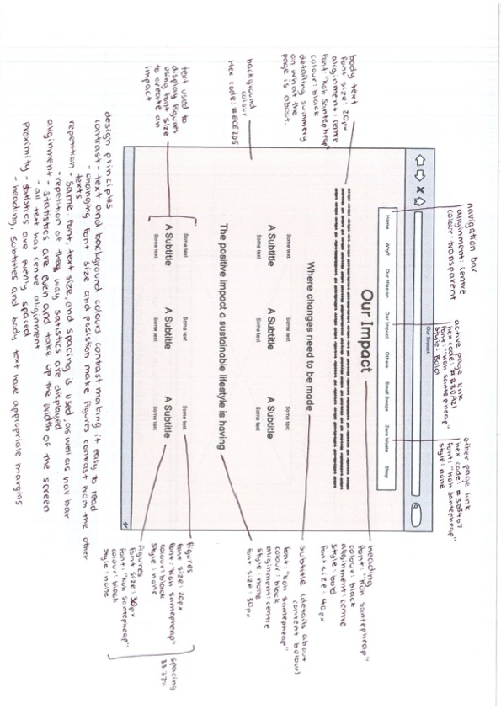

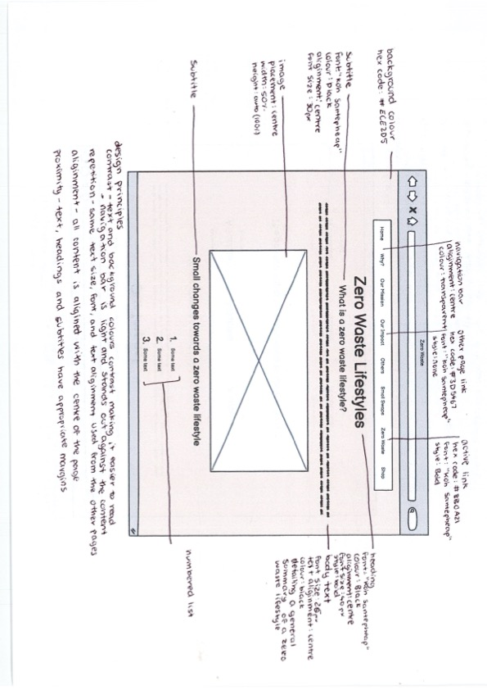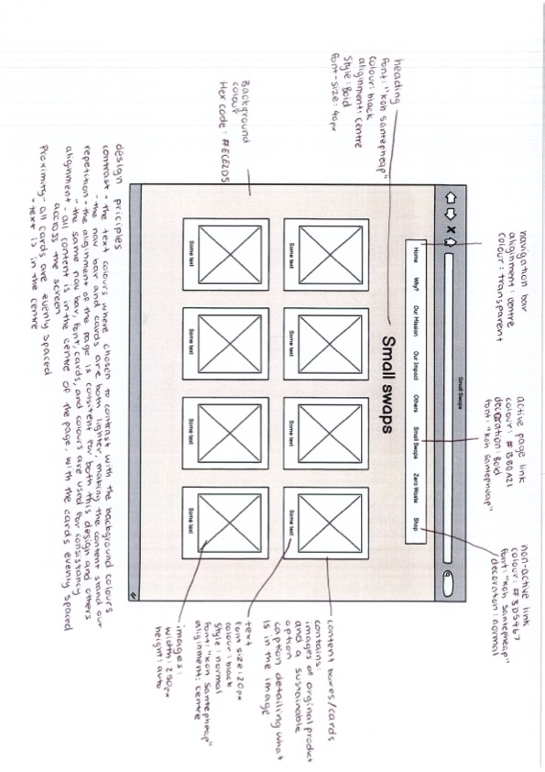

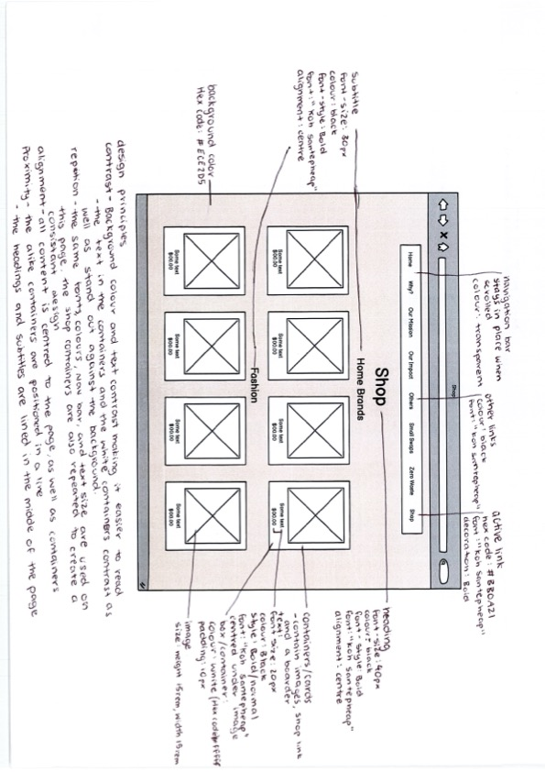

Product name: One Planet

Reasoning: This website focuses on individuals building a sustainable lifestyle, the name ‘One Planet’ was chosen as there is only one planet earth. This name is reiterating the message of making sustainable choices which will better for the environment and us in the future.

Colour scheme:

After looking at other websites and the type of content that will be displayed the colour scheme below was chosen. These colours where selected for their different purposes. The first three colours, blue, bone, and green, where chosen to be the background colours/content colours. They were chosen as they are light and bright colours that relate to the product, for example green is often related to nature and the blues represent water whilst bone is more for the content and images to stand out on these tones are often related to the environment as well. The red, grey, and black where chosen as text. The red is for active links as it stands out the most and the black is for all body and headings. The lighter grey is for non-active links.

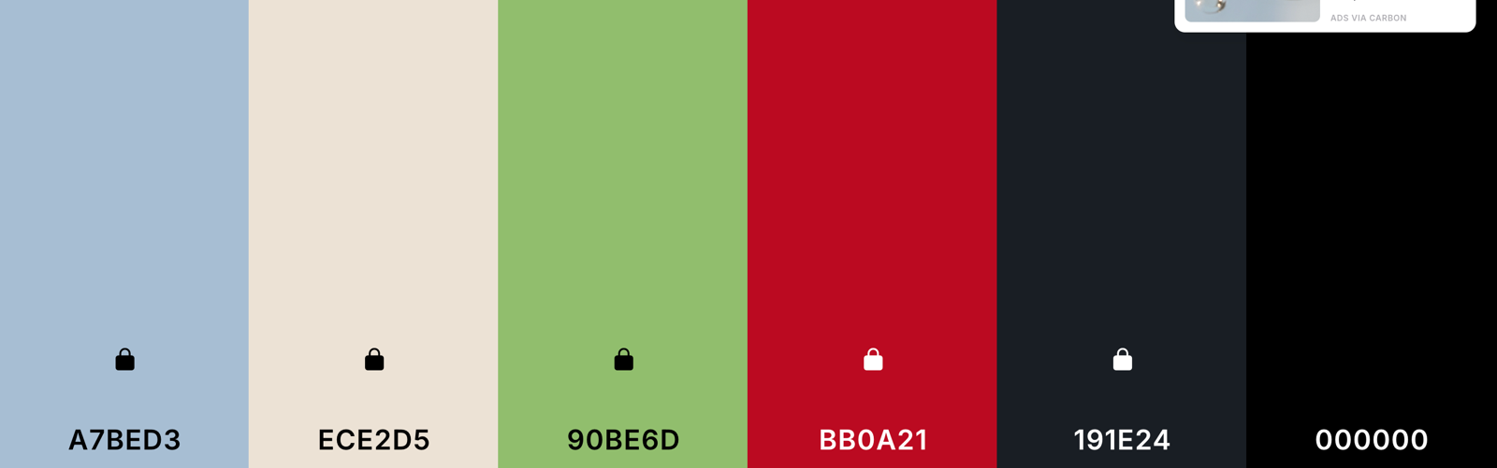

Font: Koh Santepheap

This was used for all text on the website as it is easy to read but still has some interest in the style of the font which is shown through the bolder texts. This same font will be used throughout the pages as it will keep the design consistent; to show the difference between body and headings both the size and weight of the font will be changed.

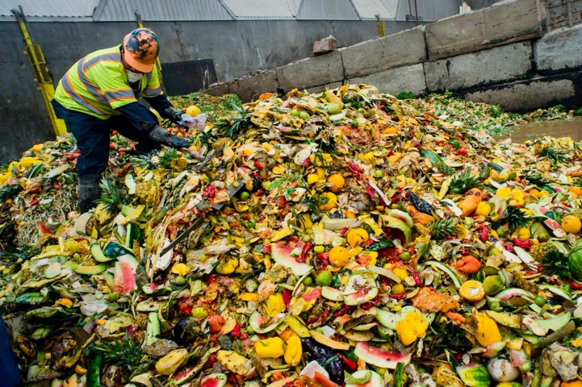Images:

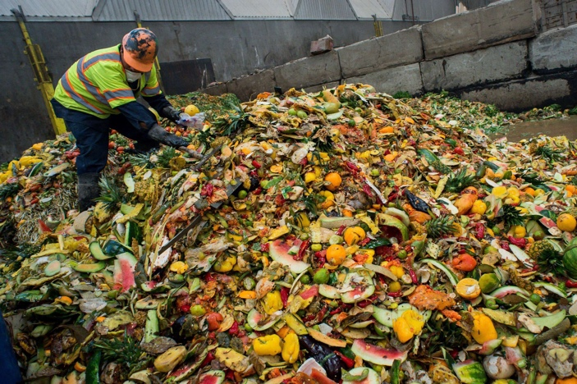

The main manipulation made to the images was cropping them or converting them into PNGs. This was done for the images to fit within the page. The above image shows how the image was edited to have brighter colours, matching the rest of the elements better.

Site map

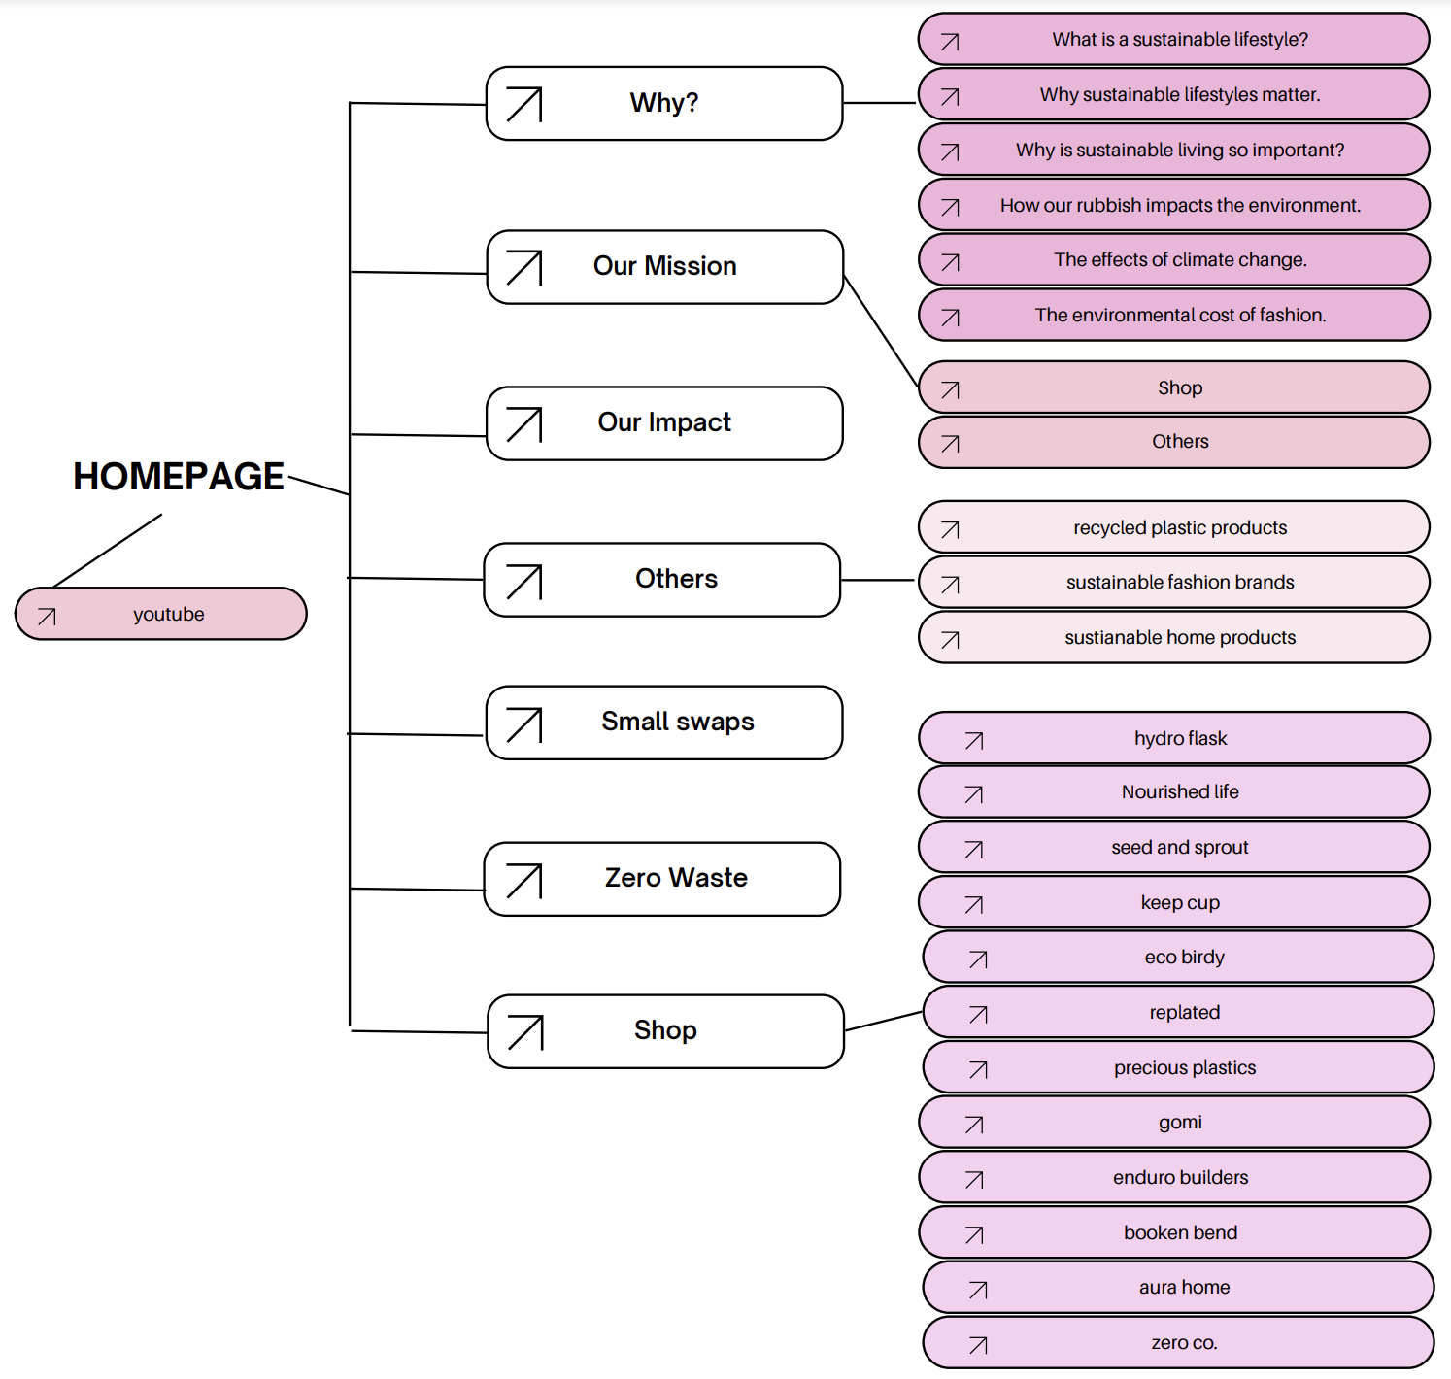

*Devising summary*

The website created will be titled ‘One Planet’, insinuating that there is only one planet, and we have to work together to save it. This website consists of 8 pages, including a ‘home’ page, this links all pages and creates a general overview of what to expect within the website. ‘Why?’ page, this details both what is a sustainable lifestyle and our impact on the environment, this page is second on the website as it provides and overview on the issues discussed throughout the rest of the pages as well as many external links to articles where readers can gather more knowledge. The next page ‘Our Mission’ speaks of the website One Planet’s aim to help young people build a sustainable lifestyle, detailing the impact and where to find companies which help to achieve this. ‘Our Impact’ page is used to display figures, demonstrating to readers just how harmful many everyday practices are to the environment and how small changes make huge impacts. The following pages ‘others’ and ‘small swaps’ detail products that are better options for their environmental impact, showing how easy making an impact is. The page ‘zero waste’ details a more extreme type of sustainable lifestyle and the small steps to achieving this. The final page is the 'shop’ tab here all the products mentioned through the website and linked, including prices, and websites. The layout, products, pages and images where all taken into consideration when designing to reach the target audience of young adults. Creating pages with small amounts of information to displaying only important facts allows for the page to be quickly read and understood, with things like colour and images making the website more appealing to read. Each page design was carefully considered for both functionality and the information in which is displays, as shown above in the wireframes the placement of each element allows for the pages to be easily read, and information to be absorbed through the use of design principles such as contrast and alignment. Each page uses the same font sizes, colours, and styles to show a consistent design that is simple for the information to stand out. The text and page colours were chosen to contrast so the pages are easy to read and the images used both reflect the aim of the website and where placed in locations that aid the readers.

Word count: 394

*Producing*

*Annotated changes*

Page 1 - Home page

The landing page was done using long page navigation. The use of contrasting colours was evident in the wireframes and used to create eye catching and effective page.

Design techniques:

* Pattern
* Balance
  + 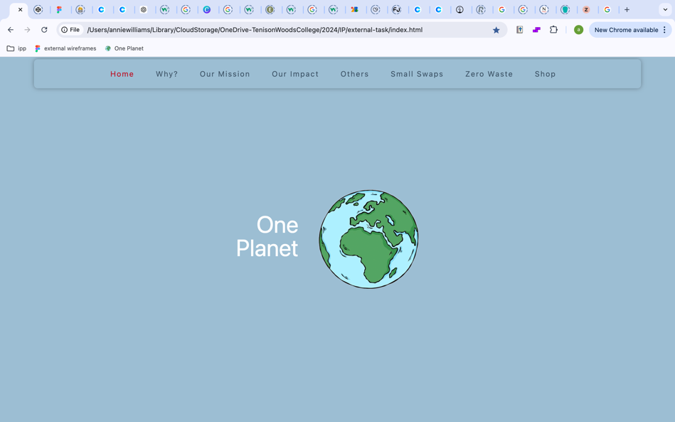All carry the same visual weight

The design started out with the incorrect font, and the white did not stand out against the background enough. The image was too small for the size of the page and overall, the first draft of this page was not what was shown in the wireframes, with the image being beside the text and not below. As shown in the image the text did not stand out and was lost within the background.

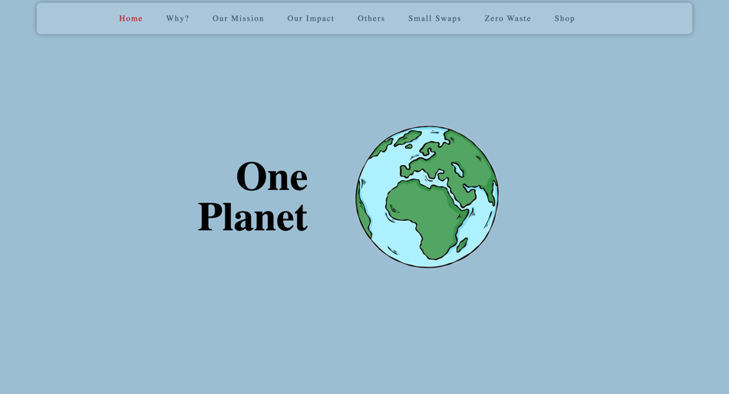

The then altered design displayed the text in a way that was much easier to read and stood out against the background colour. The text was also changed to the correct font used on the rest of the pages. From the wireframes to the final of the landing page only the position of the image was changed, as it was better displayed this way and created more visual interest.

Page 2 - Why?

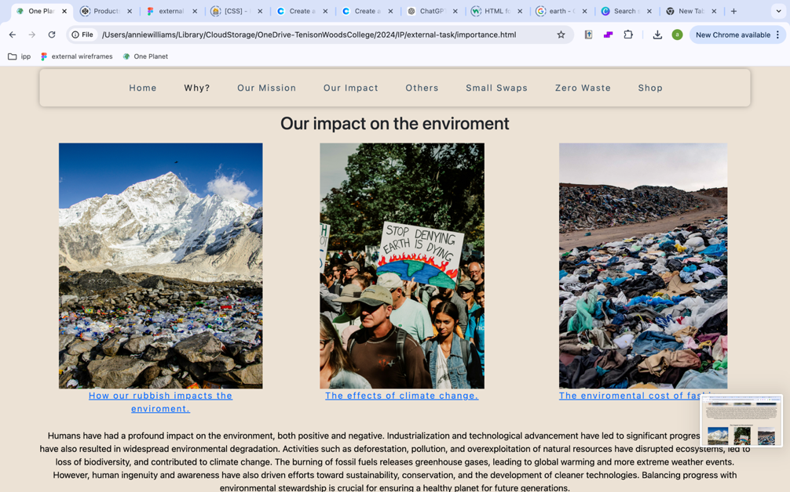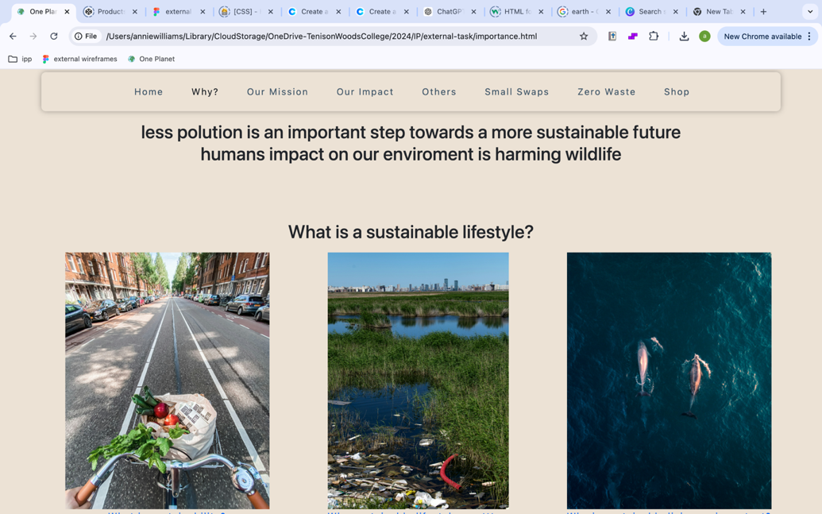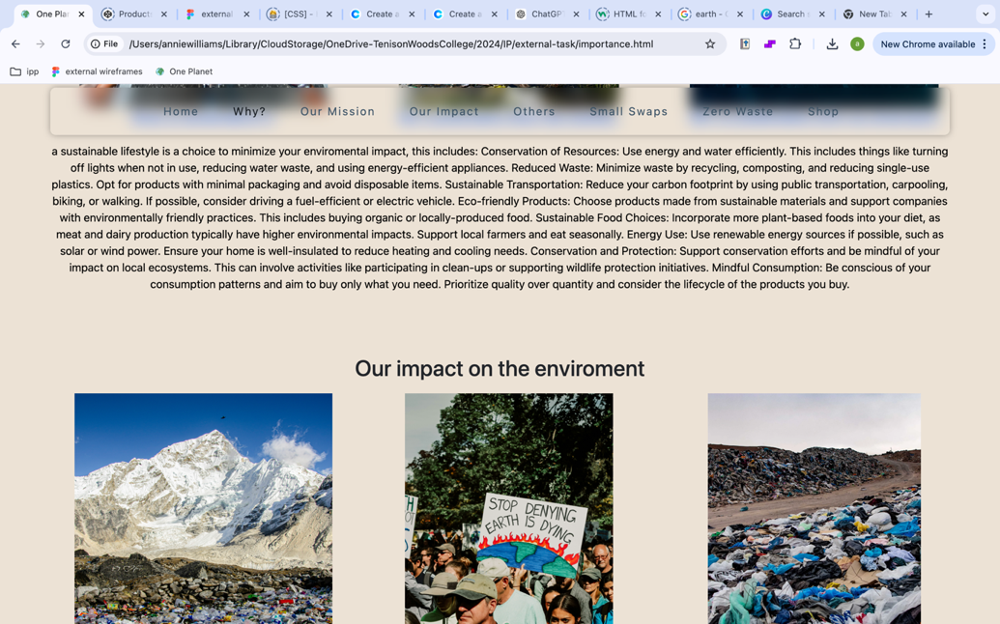

The first design of this page was very similar to the wireframes, but there were some issues with the images as they were too large to load. The overall layout of the page was functional but could be displayed better.

Design principles used:

* Contrast
* Repetition
* White space

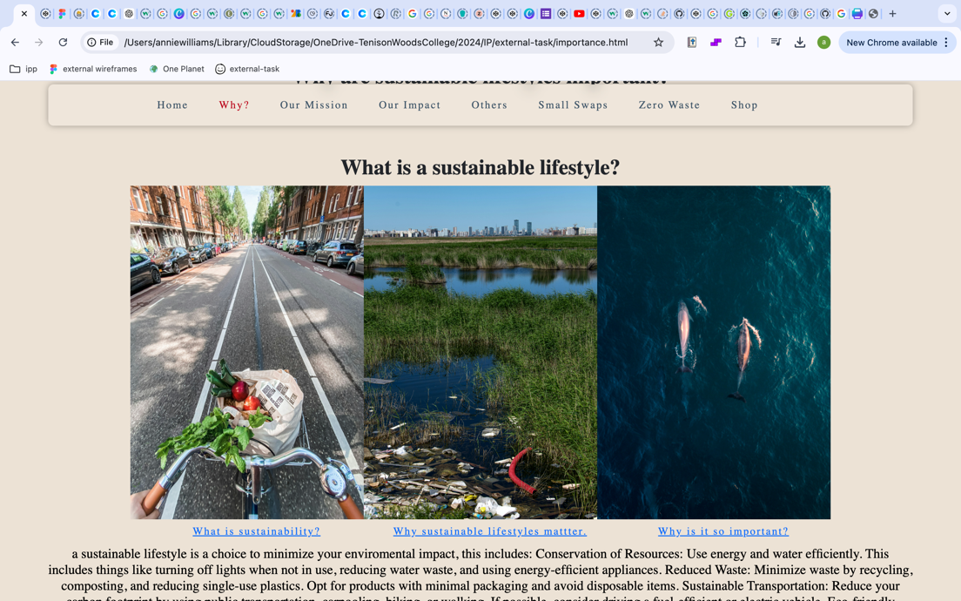

The images where then changed because collecting the images together created more of a break between the sections of the page and when creating the website this page’s proximity looked different from the others so grouping them closer together made the design more consistent. The font was also changed to match the other pages.

Page 3 – Our Mission

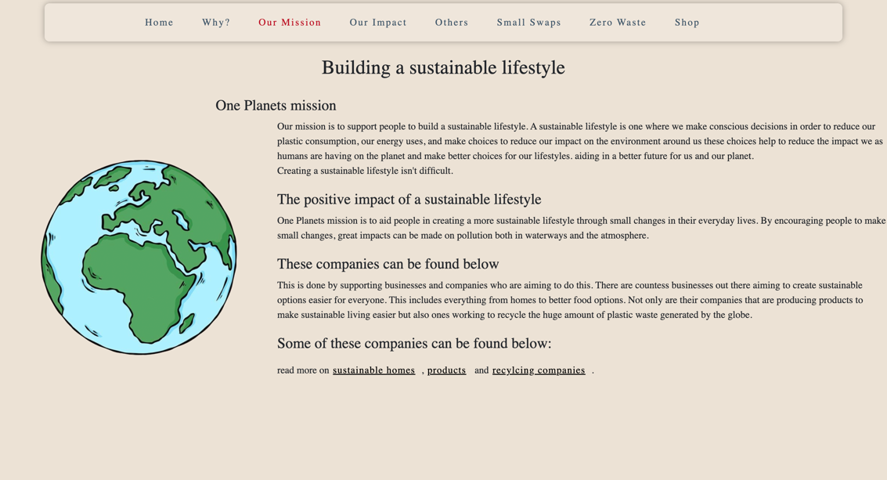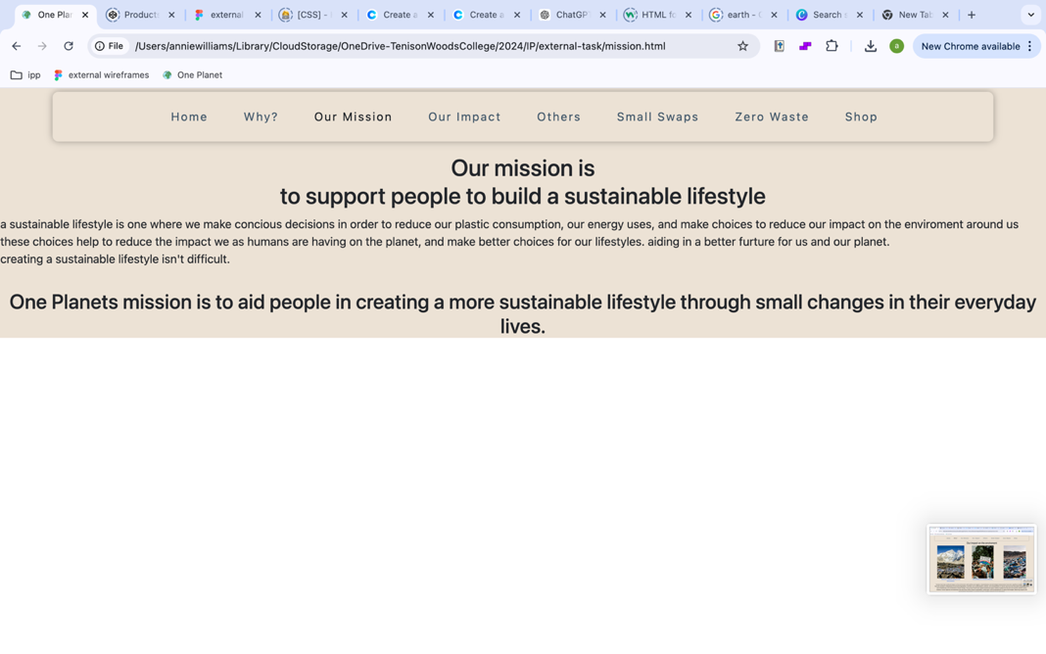This page depicts information about the ‘company’ and the aim of the website. Originally this was small, and the text was not displayed in a way that was easy to read and looked nice. Not having an image to accompany this page made the information look like a block of text on a plain page.

To fix these issues an image was added to the left of the screen. The text surrounds the image and is the correct font and size. This made the page much easier to read and nicer to look at, but the text needed to be changed so the paragraphs had more difference between them.

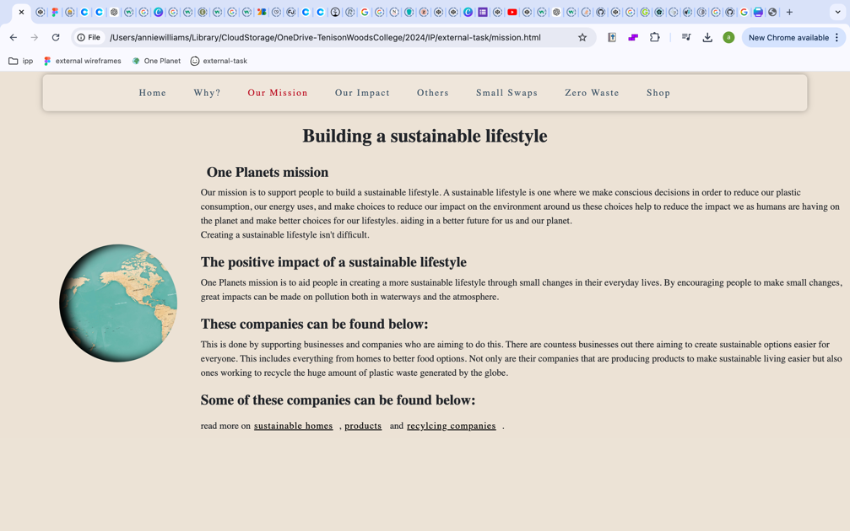To create more difference between the text the paragraph heading where changed to bold and an animation was added alongside the text. The final product of this page is very similar to the wireframes above.

Design techniques:

* Typography
* White space

Page 4- Our impact

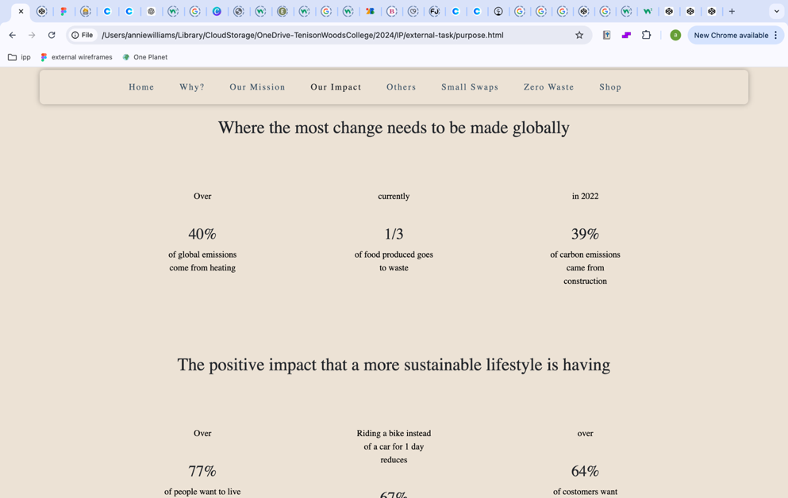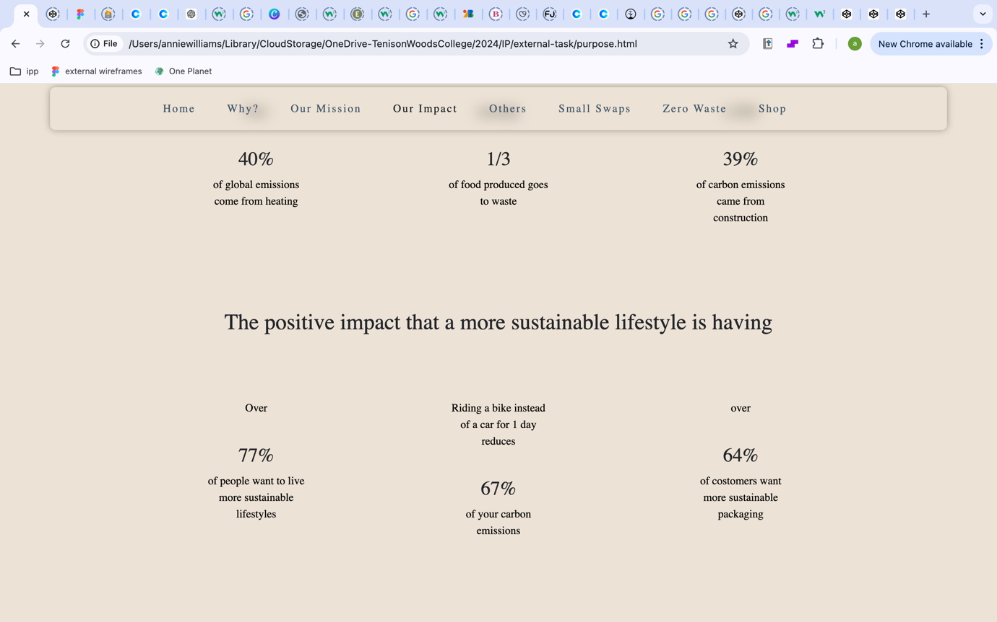

This page shows statics and the contrasting amounts of the impact living a more sustainable lifestyle has. Displaying the statistics in a way that is easy to read and eye catching. To improve this page from the first draft, more text should be added to create more understanding as the what the statistics are about and overall make it more presentable.

To improve this page and create more interest and image slideshow was added alongside the statistics to aid in both the readers understanding of the significance of these statistics and to create more interest. The also now change colour when hovered over to create more emphasis on the issues as shown.

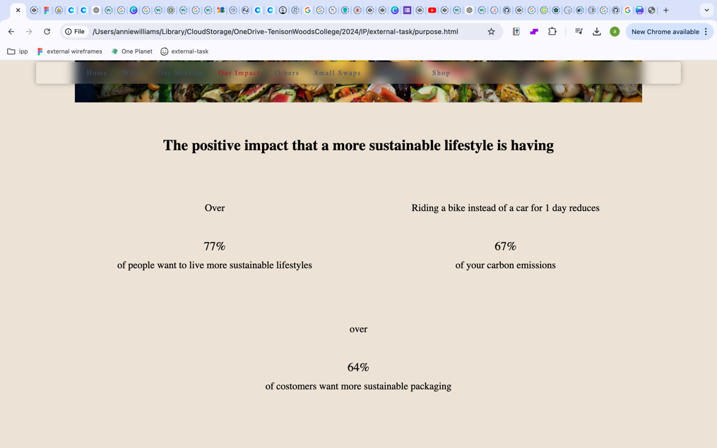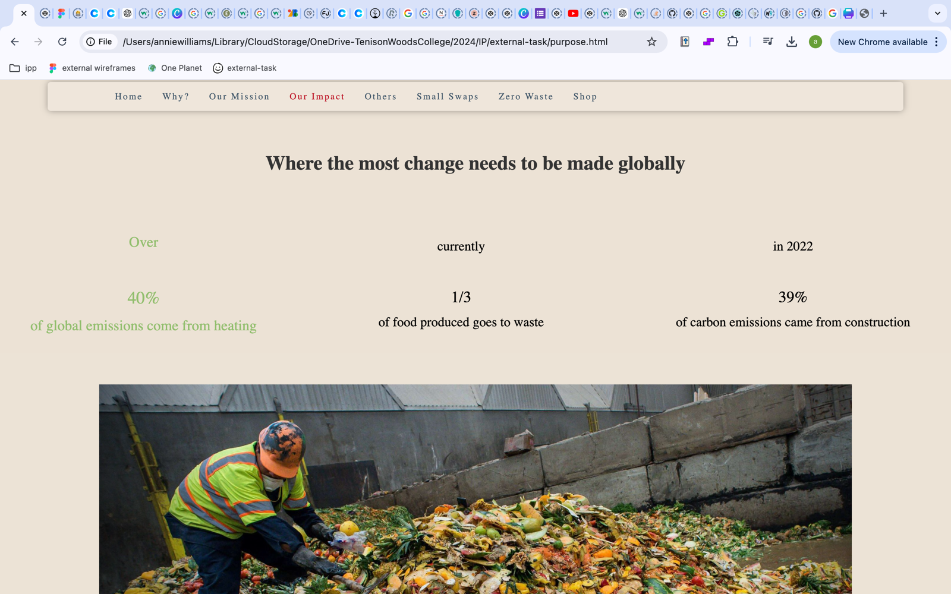

Design techniques:

* Emphasis
* Contrast
* Hierarchy

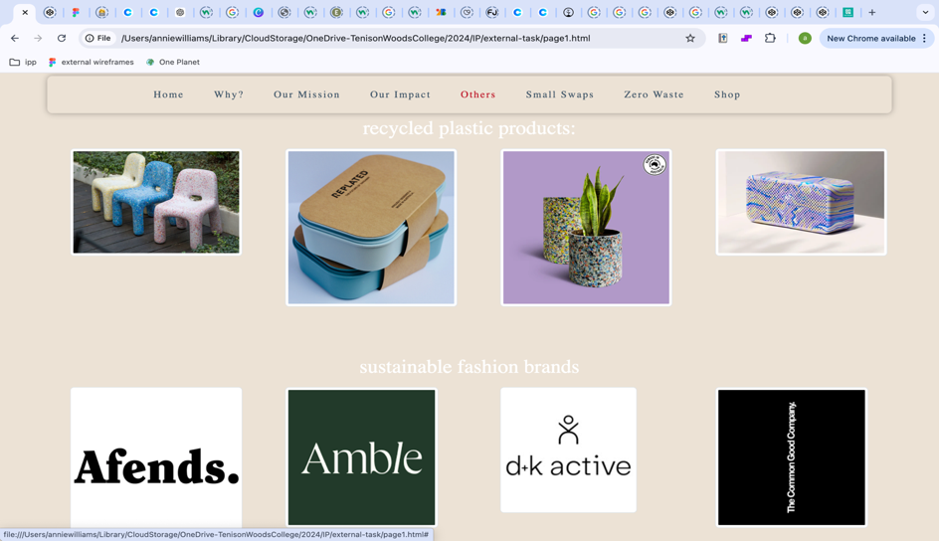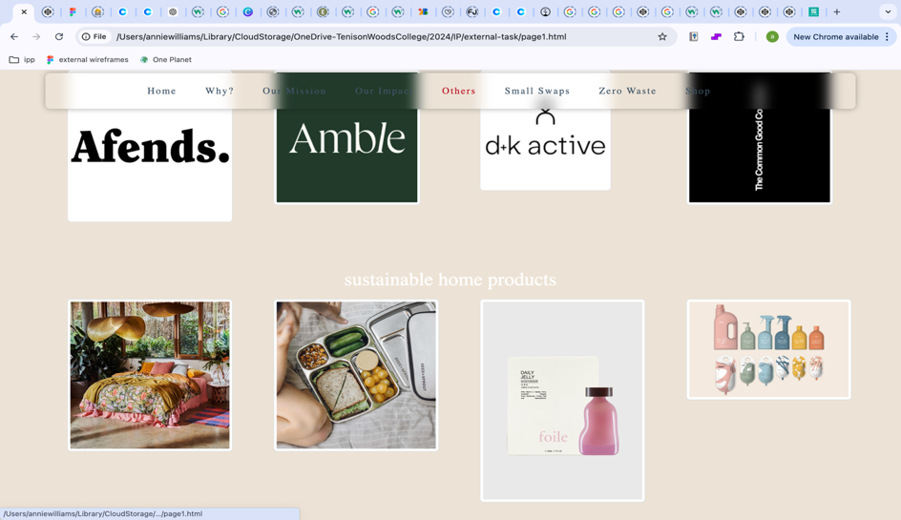

Page 5 – Others

This shows other brands and companies doing similar missions to the company created ‘one planet’. Showing other missions to helping people live a more sustainable lifestyle. The page was aimed to showcase these other brands through images that link to the shop page. Although this page was the same as the wireframes there where some changes that needed to be made, the text needed to be changed to black and bold, paragraphs supporting the images shown where also added to create a reason for this page.

The final product of this page looks different to the original idea but still applies the same design principles. The changes made overall make the design both look and function better.

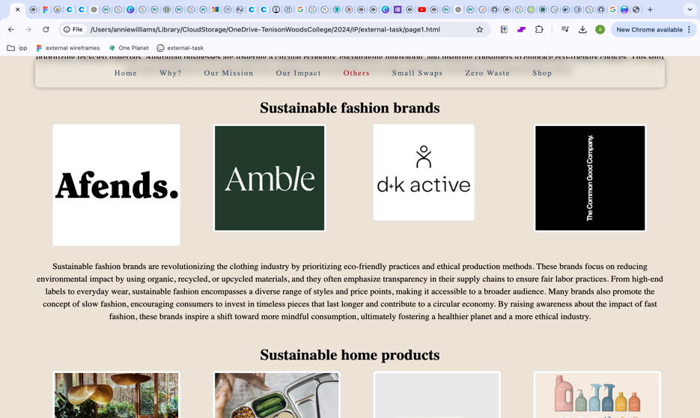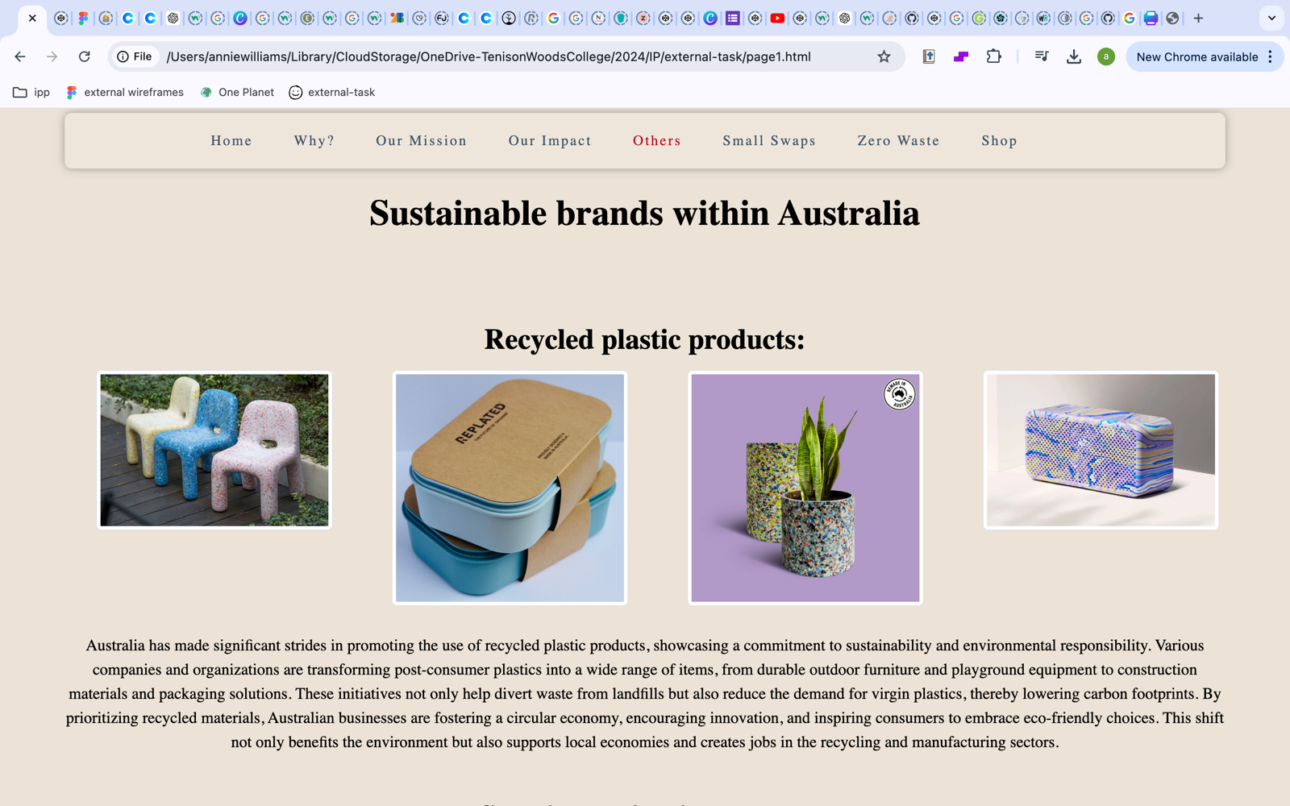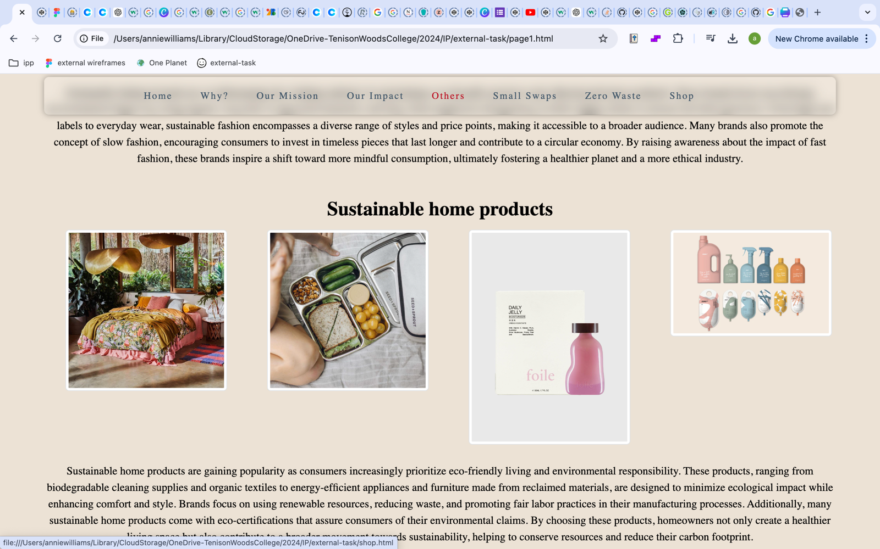

Design principles:

* Repetition
* Variety
  + Through image choice

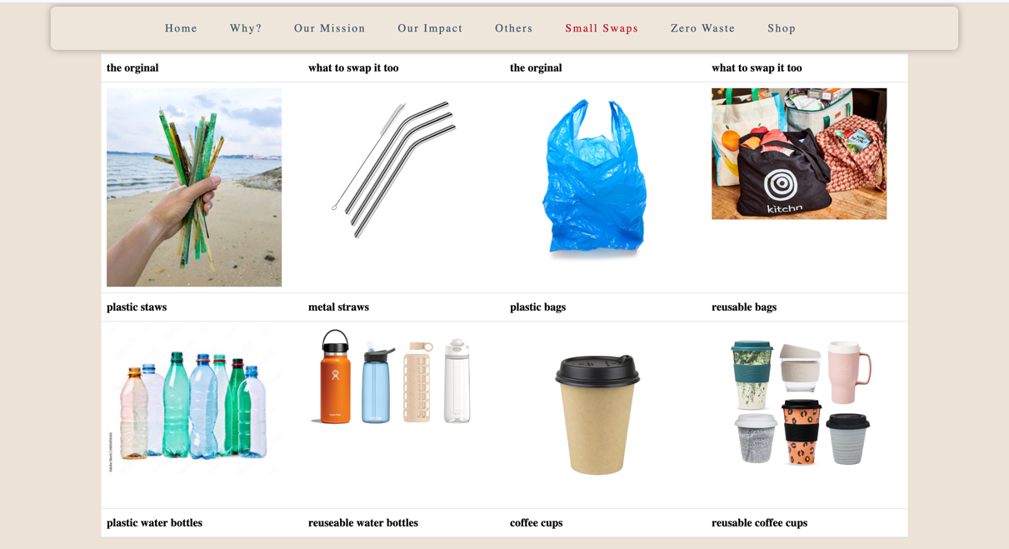

Page 6 – Small Swaps

This page uses a bootstrap table to display old products and a more sustainable options side by side.

The first draft showcases this affectively but there are some changes to be made such as the table should be the same colour as the background.

The final product of this page does not really differ from the first draft. The only major difference is the paragraph below discussing the significance of the small changes mentioned above. This helped create a longer page and overall this design is very similar to the wireframes.

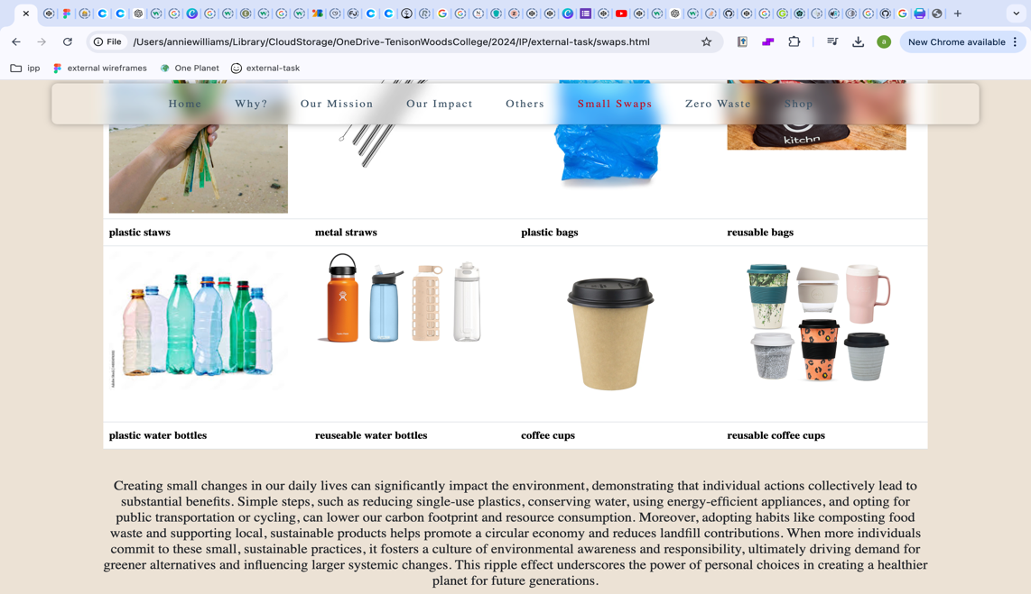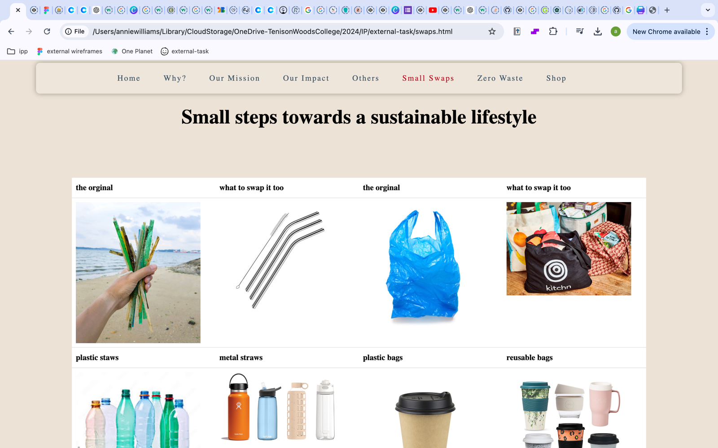

Design principles:

* Balance
* Repetition
* Rhythm

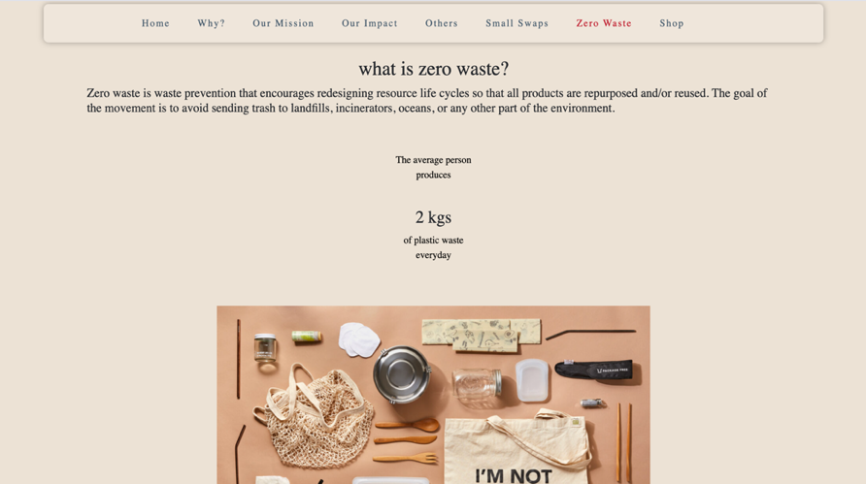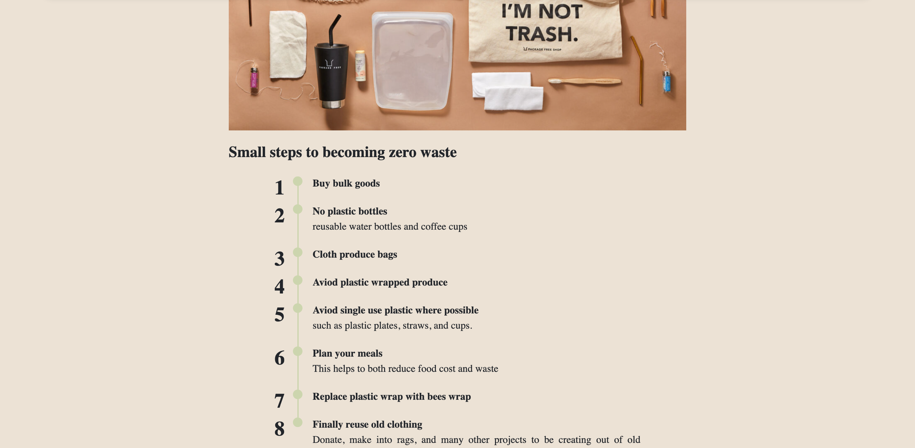

Page 7 – Zero Waste

This details a zero-waste lifestyle, using a combination of different presentations such as lists, images, and body texts. The page is very similar to the wireframe and depicts all the information it should.

Design principles:

* White space
* Hierarchy
* emphasis

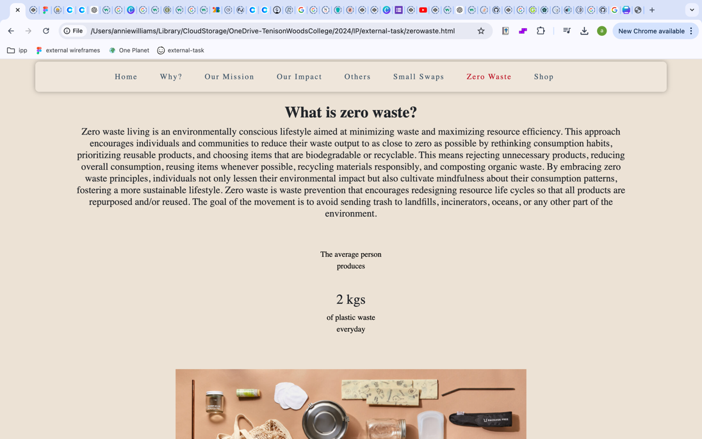

The only changes made to this page was adding more text and creating bold headings. The changes made make the page look more complete and the text easier to read.

Page 8 – Shop

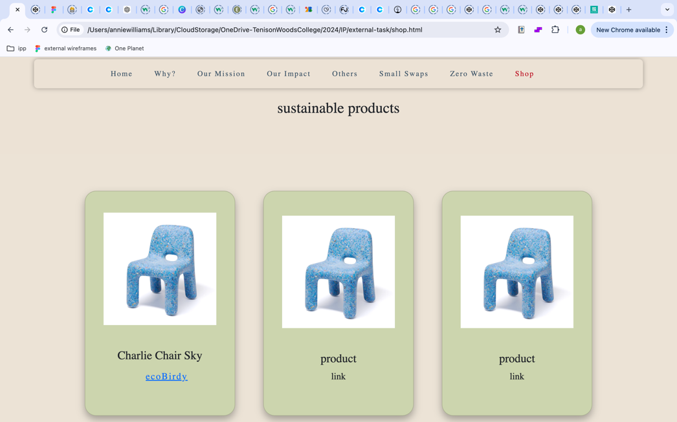A shop page using bootstrap card to show the products and stuff detailed on other pages.

The cards where orginally in green with and did not show the content in a way that matched the rest of the website. They also didn’t look like show cards as the links were text.

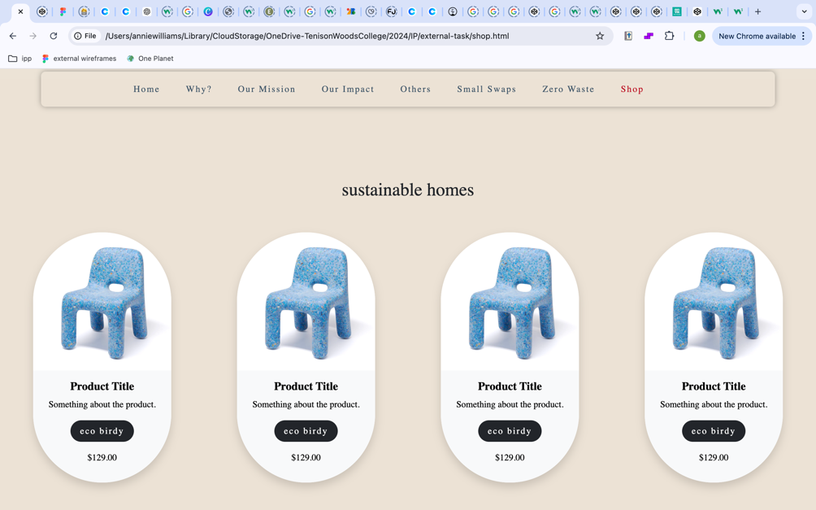

The new bootstrap cards were better presented and created better unity within the design as the images fitted better within the cards.

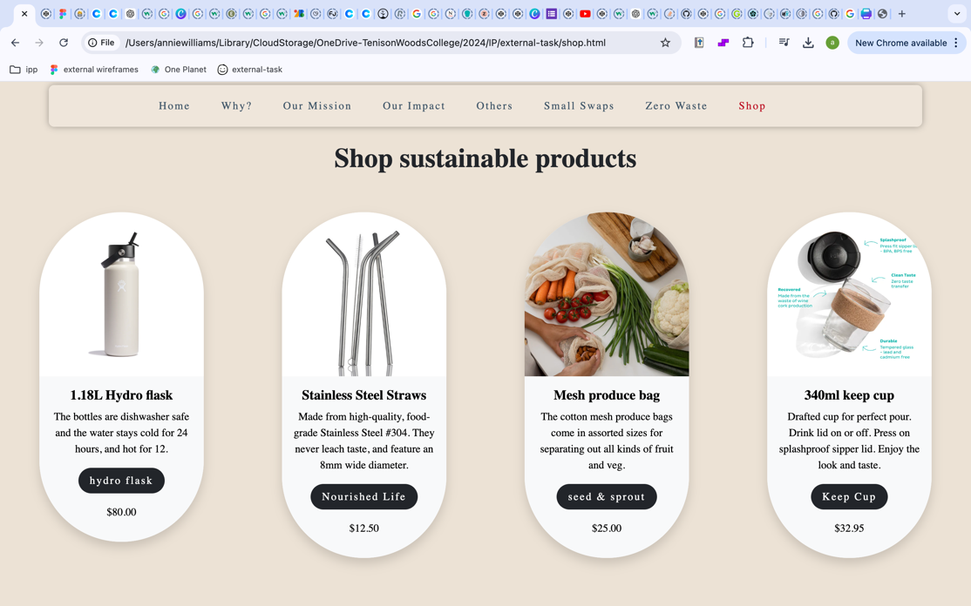The final page looked much more organised with the different cards and to create the overall page only a few changes were made. This was creating the subheadings above each section of the shop. These needed to be larger and in bold to create the best effect.

Design principles:

- unity

- consistency

- contrast

*Word dump*

*Home*

One Planet

There is only one planet.  
Creating a sustainable lifestyle helps build a better future for us and the planet.  
The ever-growing issue of plastic pollution is harming animals, the environment, and us.

Through small changes within our own lifestyles, we can all make a difference.  
These changes include zero waste living and the many things we can do to reduce or footprint.

Be a part of the change.

*Why?*

Why are sustainable lifestyles important?

What is a sustainable lifestyle?

a sustainable lifestyle is a choice to minimize your environmental impact, this includes: Conservation of Resources: Use energy and water efficiently. This includes things like turning off lights when not in use, reducing water waste, and using energy-efficient appliances. Reduced Waste: Minimize waste by recycling, composting, and reducing single-use plastics. Opt for products with minimal packaging and avoid disposable items. Sustainable Transportation: Reduce your carbon footprint by using public transportation, carpooling, biking, or walking. If possible, consider driving a fuel-efficient or electric vehicle. Eco-friendly Products: Choose products made from sustainable materials and support companies with environmentally friendly practices. This includes buying organic or locally produced food. Sustainable Food Choices: Incorporate more plant-based foods into your diet, as meat and dairy production typically have higher environmental impacts. Support local farmers and eat seasonally. Energy Use: Use renewable energy sources if possible, such as solar or wind power. Ensure your home is well-insulated to reduce heating and cooling needs. Conservation and Protection: Support conservation efforts and be mindful of your impact on local ecosystems. This can involve activities like participating in clean-ups or supporting wildlife protection initiatives. Mindful Consumption: Be conscious of your consumption patterns and aim to buy only what you need. Prioritize quality over quantity and consider the lifecycle of the products you buy.

Our impact on the environment

Humans have had a profound impact on the environment, both positive and negative. Industrialization and technological advancement have led to significant progress, but they have also resulted in widespread environmental degradation. Activities such as deforestation, pollution, and overexploitation of natural resources have disrupted ecosystems, led to loss of biodiversity, and contributed to climate change. The burning of fossil fuels releases greenhouse gases, leading to global warming and more extreme weather events. However, human ingenuity and awareness have also driven efforts toward sustainability, conservation, and the development of cleaner technologies. Balancing progress with environmental stewardship is crucial for ensuring a healthy planet for future generations.

*Our Mission*

Building a sustainable lifestyle

One Planets mission

Our mission is to support people to build a sustainable lifestyle. A sustainable lifestyle is one where we make conscious decisions in order to reduce our plastic consumption, our energy uses and make choices to reduce our impact on the environment around us these choices help to reduce the impact we as humans are having on the planet and make better choices for our lifestyles. aiding in a better future for us and our planet.  
Creating a sustainable lifestyle isn't difficult.

The positive impact of a sustainable lifestyle

One Planets mission is to aid people in creating a more sustainable lifestyle through small changes in their everyday lives. By encouraging people to make small changes, great impacts can be made on pollution both in waterways and the atmosphere.

These companies can be found below:

This is done by supporting businesses and companies who are aiming to do this. There are countess businesses out there aiming to create sustainable options easier for everyone. This includes everything from homes to better food options. Not only are their companies that are producing products to make sustainable living easier but also ones working to recycle the huge amount of plastic waste generated by the globe.

Some of these companies can be found below:

read more on [sustainable homes](shop.html), [products](shop.html) and [recycling companies](page1.html).

*Our impact*

Where the most change needs to be made globally

Over 40% of global emissions come from heating

Currently 1/3 of food produced goes to waste

in 2022 39% of carbon emissions came from construction

The positive impact that a more sustainable lifestyle is having

Over 77% of people want to live more sustainable lifestyles

Riding a bike instead of a car for 1 day reduces 67% of your carbon emissions

Over 64% of costumers want more sustainable packaging

*Others*

Sustainable brands within Australia

Recycled plastic products:

Australia has made significant strides in promoting the use of recycled plastic products, showcasing a commitment to sustainability and environmental responsibility. Various companies and organizations are transforming post-consumer plastics into a wide range of items, from durable outdoor furniture and playground equipment to construction materials and packaging solutions. These initiatives not only help divert waste from landfills but also reduce the demand for virgin plastics, thereby lowering carbon footprints. By prioritizing recycled materials, Australian businesses are fostering a circular economy, encouraging innovation, and inspiring consumers to embrace eco-friendly choices. This shift not only benefits the environment but also supports local economies and creates jobs in the recycling and manufacturing sectors.

Sustainable fashion brands

Sustainable fashion brands are revolutionizing the clothing industry by prioritizing eco-friendly practices and ethical production methods. These brands focus on reducing environmental impact by using organic, recycled, or upcycled materials, and they often emphasize transparency in their supply chains to ensure fair labor practices. From high-end labels to everyday wear, sustainable fashion encompasses a diverse range of styles and price points, making it accessible to a broader audience. Many brands also promote the concept of slow fashion, encouraging consumers to invest in timeless pieces that last longer and contribute to a circular economy. By raising awareness about the impact of fast fashion, these brands inspire a shift toward more mindful consumption, ultimately fostering a healthier planet and a more ethical industry.

Sustainable home products

Sustainable home products are gaining popularity as consumers increasingly prioritize eco-friendly living and environmental responsibility. These products, ranging from biodegradable cleaning supplies and organic textiles to energy-efficient appliances and furniture made from reclaimed materials, are designed to minimize ecological impact while enhancing comfort and style. Brands focus on using renewable resources, reducing waste, and promoting fair labour practices in their manufacturing processes. Additionally, many sustainable home products come with eco-certifications that assure consumers of their environmental claims. By choosing these products, homeowners not only create a healthier living space but also contribute to a broader movement towards sustainability, helping to conserve resources and reduce their carbon footprint.

*Small swaps*

Small steps towards a sustainable lifestyle

Creating small changes in our daily lives can significantly impact the environment, demonstrating that individual actions collectively lead to substantial benefits. Simple steps, such as reducing single-use plastics, conserving water, using energy-efficient appliances, and opting for public transportation or cycling, can lower our carbon footprint and resource consumption. Moreover, adopting habits like composting food waste and supporting local, sustainable products helps promote a circular economy and reduces landfill contributions. When more individuals commit to these small, sustainable practices, it fosters a culture of environmental awareness and responsibility, ultimately driving demand for greener alternatives and influencing larger systemic changes. This ripple effect underscores the power of personal choices in creating a healthier planet for future generations.

*Zero Waste*

What is zero waste?

Zero waste living is an environmentally conscious lifestyle aimed at minimizing waste and maximizing resource efficiency. This approach encourages individuals and communities to reduce their waste output to as close to zero as possible by rethinking consumption habits, prioritizing reusable products, and choosing items that are biodegradable or recyclable. This means rejecting unnecessary products, reducing overall consumption, reusing items whenever possible, recycling materials responsibly, and composting organic waste. By embracing zero waste principles, individuals not only lessen their environmental impact but also cultivate mindfulness about their consumption patterns, fostering a more sustainable lifestyle. Zero waste is waste prevention that encourages redesigning resource life cycles so that all products are repurposed and/or reused. The goal of the movement is to avoid sending trash to landfills, incinerators, oceans, or any other part of the environment.

The average person produces 2 kgs of plastic waste everyday

Small steps to becoming zero waste

1. Buy bulk goods
2. No plastic bottles
   * Use reusable water bottles and coffee cups where possible.
3. Cloth produce bags
4. Avoid plastic wrapped produce
5. Avoid single use plastic where possible

* Such as plastic plates, straws, and cups.

1. Plan your meals
   * This helps to both reduce food cost and waste
2. Replace plastic wrap with bee’s wax wrap
3. Finally reuse old clothing
   * Donate, make into rags, and many other projects to be creating out of old clothing.

*Shop*

1.18L Hydro flask

The bottles are dishwasher safe and the water stays cold for 24 hours, and hot for 12.

Stainless Steel Straws

Made from high-quality, food-grade Stainless Steel #304. They never leach taste, and feature an 8mm wide diameter.

Mesh produce bag

The cotton mesh produce bags come in assorted sizes for separating out all kinds of fruit and veg.

340ml keep cup

Drafted cup for perfect pour. Drink lid on or off. Press on splashproof sipper lid. Enjoy the look and taste.

Charlie Chair

The Charlie Chair is designed for kids. With its rounded edges, Charlie is safe and comfortable for everyone.

Duo reusable meal boxes

The perfect takeaway meal boxes made from recycled Certified Ocean Bound Plastic. Food safe and BPA free.

Recycled Riser

One of a kind piece manufactured from 100% recycled HDPE - household packaging waste.

Gomi Speaker

Handmade UK-made Bluetooth speaker made from recycled plastic, available in a wide variety of colours.

Passive Home Designer

Enduro Builders, design and create passive homes within Adelaide

Booken Blend

Sustainable and passive design workshops located in Australia.

Aura Home

The linen bedding is thoughtfully produced, focusing on sustainability and durability.

Zero Co

Plant-based and planet friendly cleaning and home products.

Word count: 1630

*Final product*



*Evaluation*

*Surveys*

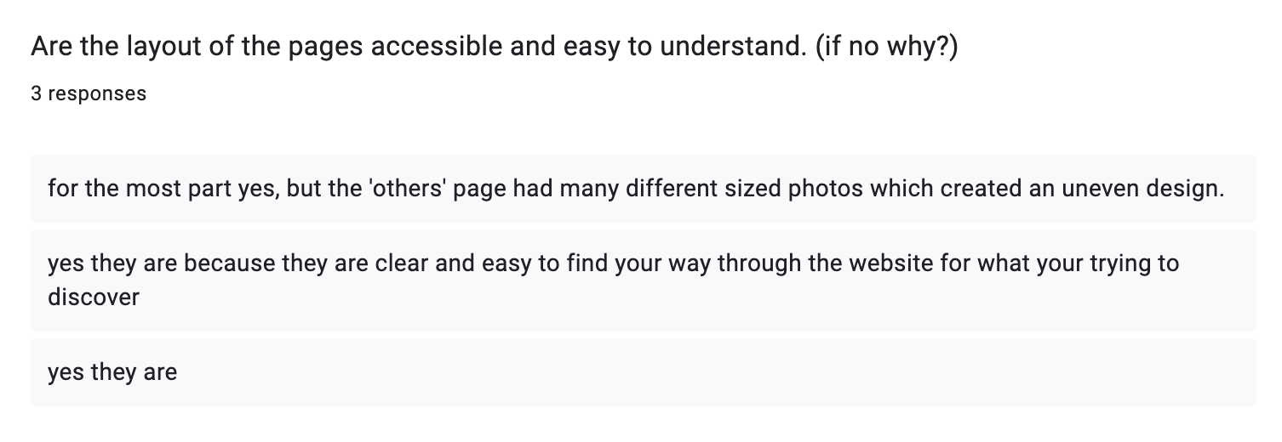The following survey was sent out to people of the target audience, the feedback provided was helpful in understanding how to create a better website and was a good way to gather a deeper insight to the target audience.

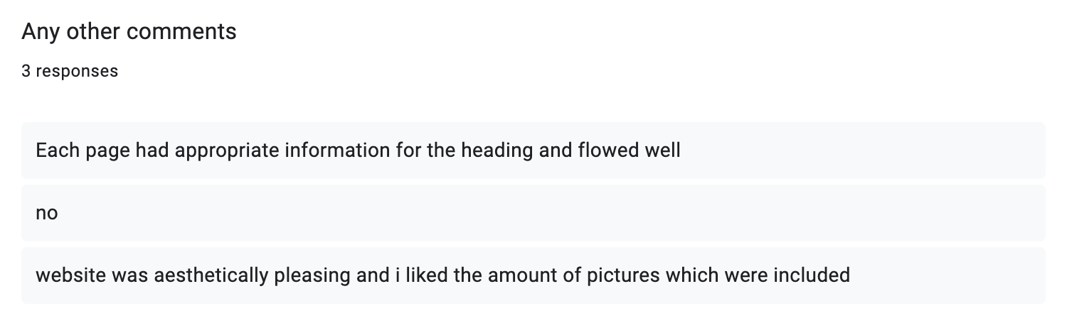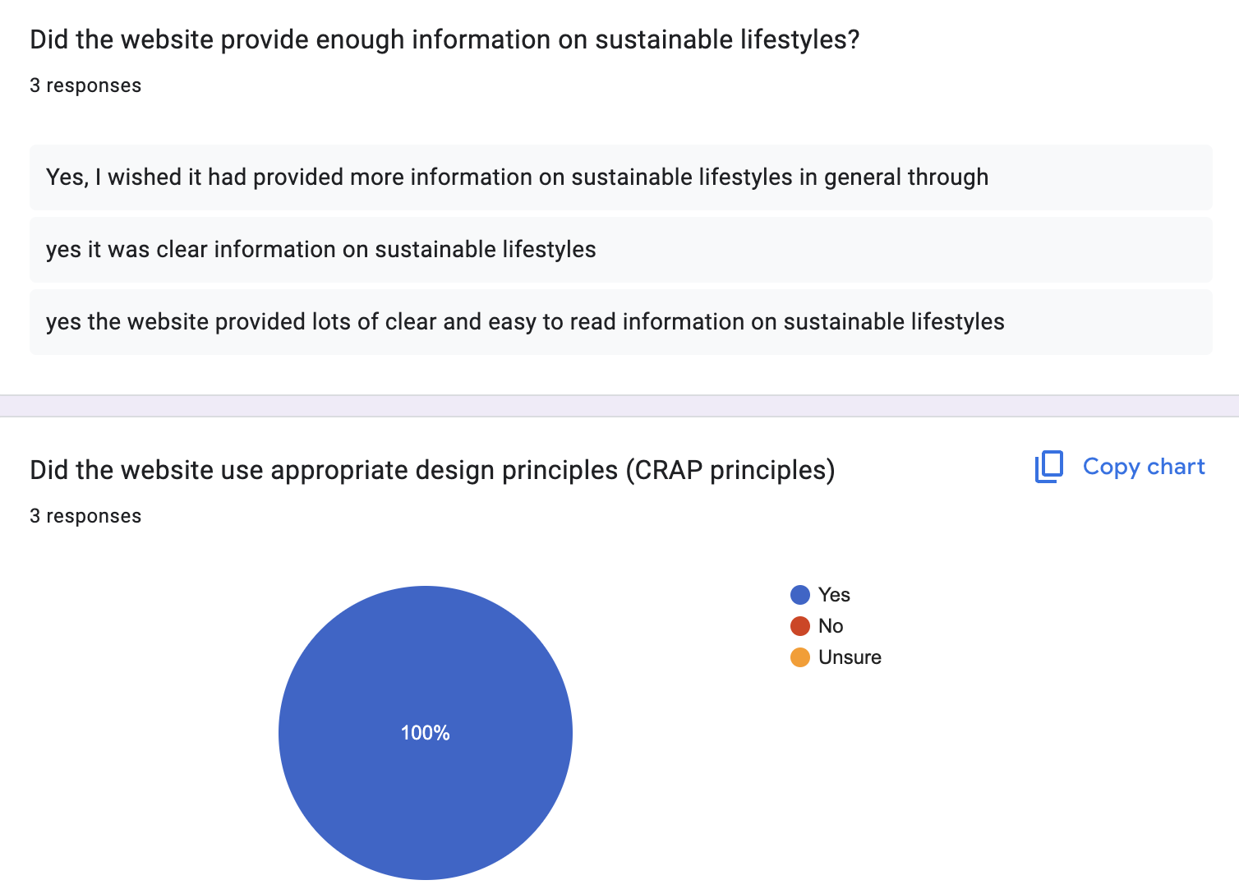*Evaluation summary*

The final product created was an 8-page website about sustainable lifestyles, including many external resources for articles, products, and information. The task required a 6–10-page website detailing about a specific topic, the product created fits the design brief and includes the elements mentioned such as, image and video lightboxes, and long page navigation. One of the most significant aspects of designing this website was it had to appeal to a target audience, the one chosen for the above website was young adults. To understand if the product communicated with the intended audience surveys where done that provided feedback, this was only done at the end through and would be more beneficial if it was done after the wireframes were created as well. The survey responses where mainly positive with some suggestions as to how to improve the ‘others’ page. Overall the survey responses show that the website reaches the target audience.

To create this website html and CSS script was used as this was software that I was familiar with and had used on multiple occasions before. Whilst this software was appropriate for the task and the final product produced is functional there were some limitations. For example, java script had to be used for one element to make it functional as it did not work without it. To create the video lightbox with the video wanted for the website it was not possible with just html script. There were other limitations encountered with using just html and CSS such as elements of animation which were a required specification for the task, were difficult to incorporate without the use of java script.

Prior to creating and designing the website, looking at other resources for similar products was beneficial as it allowed for greater understanding of what is needed within these websites. To investigate similar products allowed different design features to be explored, this resulted a more thought-out website as the content is similar to what is currently available whilst also including what was missing. By conducting research before designing the website a better understanding of design choices made by others makes it easier to create a better design ourselves. The investigating stage of this report is significant in creating a thought out and practical website that includes appropriate information and targets the correct audience. This research before anything created better wireframes for the devising part of the report, which formed a more cohesive website. The wireframes for the website where the design plans, having these to base the website off of were the design principles where already considered allowed for a much easier design process. This also allowed for all the different elements of the design to be cohesive across all 8 pages. The wireframes created where easy to follow and understand as the pieces show what elements need to be included. Once designing the website some elements did not work and these issues where easily overcome by problem solving, and the website would not be as cohesive as it is without design plans. Some of the changes that needed to be made where in regard to layout, this mainly effected the alignment of the pages and when making these changes this design principle was considered.

Throughout a large task time management is important in finishing the project on time. Whilst the design plans showed how much work needed to be done to present the website there was a lot of work that needed to be done that is not seen. So, whilst the design plans helped in understanding the large task, they did not account for the amount of work required. Throughout this whole process and all the steps required in creating this product having many different steps and checkpoints allowed for the design brief to be for filled and the task to be completed within the set timeframe. In doing this task I learnt about about time management. Deadlines where an important part in keeping on top of the workload and it was important to set these throughout, so the task was finished intime. These internal deadlines made it so I could reach the final due date of the product and only have a few elements left to finalise. If I was to do this task again, I would set myself more due dates earlier within the assessment for better time management. In designing this product if I was to do the task again, I would create a website that varies colour more and includes more design principles. Over this task I have learnt the importance of time management and how key design plans are to creating an effective design.

Word count: 773

Repository link: <https://github.com/s364198/sustainable-lifestyles>

*Bibliography*

*‌12oz/340ml Brew Cork Reusable Glass Coffee Cup | KeepCup 2024, Keepcup Australia, viewed 18 August 2024, <https://au.keepcup.com/brew-cork-12oz?sku=BCFRA12>.*

*2019, Balsamiq.cloud, viewed 22 August 2024, <https://balsamiq.cloud/s90g9y2/ps5r5u2/rF106>.*

*Chrisoulis, K 2023, 12 Australian brands making your home environmentally conscious, Fashion Journal, viewed 9 September 2024, <https://fashionjournal.com.au/life/earth-day-australian-brands/>.*

*Coolors.co 2015, Coolors.co, viewed 10 October 2024, <https://coolors.co/a7bed3-ece2d5-90be6d-bb0a21-191e24-000000>.*

*Housekeeping Archives - Wasteland Rebel 2020, Wasteland Rebel, viewed 9 September 2024, <https://wastelandrebel.com/category/housekeeping/>.*

*in 2015, Sustainability in everyday life | Sustainability, YouTube, viewed 20 September 2024, <https://www.youtube.com/watch?v=kZIrIQDf1nQ>.*

*Koh Santepheap - Google Fonts 2024, Google Fonts, viewed 3 August 2024, <https://fonts.google.com/specimen/Koh+Santepheap?query=Koh+Santepheap>.*

*Lifestyle • Sustainable Jungle 2020, Sustainable Jungle, viewed 18 October 2024, <https://www.sustainablejungle.com/lifestyle/>.*

*Powell, O 2022, 4 CRAP Design Principles For A Better UX - Attention Insight, Attention Insight, viewed 20 September 2024, <https://attentioninsight.com/crap-design-principles/#:~:text=C.R.A.P.%20is%20an%20acronym%20coined,an%20e%2Dbook%2C%20etc.>.*

*rePlated 2024, rePlated, viewed 10 October 2024, <https://shop.replated.co/>.*

*s364198/sustainable-lifestyles 2024, GitHub, viewed 20 September 2024, <https://github.com/s364198/sustainable-lifestyles>.*

*Stainless Steel Straws 2024, Nourished Life, viewed 22 August 2024, <https://www.nourishedlife.com.au/products/life-basics-by-nourished-life-stainless-steel-straws?gad_source=1&gclid=Cj0KCQjwi5q3BhCiARIsAJCfuZkbHrNIfxWqpkmOeZ67uaXabNhDdzPFRsN8UiVWaWCfmvgOvKlFFNAaAlx9EALw_wcB>.*

*sustainable living website 2024, Google Docs, viewed 18 August 2024, <https://docs.google.com/forms/d/1ExSwz_58ulwTQBpKq7ALXB5G-6e3dBYq26CYvOXdBbs/edit?pli=1#responses>.*

*W3Schools.com 2023, W3schools.com, viewed 9 September 2024, <https://www.w3schools.com/>.*

*Weeden, M 2024, How to Reduce Waste: 21 Ideas for Zero Waste Living, One Tree Planted, viewed 18 October 2024, <https://onetreeplanted.org/blogs/stories/how-to-reduce-waste>.*

*What is a sustainable lifestyle? 2018, Canva, viewed 19 August 2024, <https://www.canva.com/design/DAGT5m46e5c/HfTmfwK_VzXWPNfkKJMGog/edit>.*

*Zero Waste for Beginners Archives - Going Zero Waste 2024, Going Zero Waste, viewed 18 October 2024, <https://www.goingzerowaste.com/blog-posts-for-beginners/>.*

*Zero, GF 2022, Go For Zero, Go For Zero, viewed 18 October 2024, <https://goforzero.com.au/>.*

*‌*